**Practice Test Paper- HTML**

1) HTML Stands for : Hyper Text Markup Language

2) What is current version of HTML: HTML5

3) IDE Stands for: Integrated Development Environment

4) Which IDE Is Suitable IDE to develop web applications: Visual Studio Code

5) CSS Stans for: Cascading Style Sheets

6) Why CSS? Write minimum 3 points

* It is Free.
* No dependency on java script
* Effective design
* Adjustable layout and size
* Reusable

7) What is the Current version of CSS : CSS3

8) What is Bootstrap?

Bootstrap is the most popular HTML, CSS and JavaScript framework for developing a responsive and mobile friendly website.

9) What is Angular?

Front-end web framework developed by Google for building dynamic web applications

10) What is React?

JavaScript library developed by Facebook for building user interfaces, particularly single-page applications.

11)Explain MEAN Stack?

**M**: MongoDB

**E**: Express.js

**A**: Angular

**N**: Node.js

13) Explain MEVN Stack?

M: MongoDB

E: Express.js

v: Vue.js

N: Node.js

14) Write Features of HTML5.X?

* New form types like email, date, and number, along with built-in validation features.
* Enables drawing graphics, animations, and complex visualizations on the fly using JavaScript
* <section>, <header> and <footer>, which provide better document structure.

15) Explain Semantic Elements in HTML5 with Diagram?

* <header>: Represents the header section of a webpage or section.
* <nav>: Represents a navigation block for internal/external links.
* <article>: Represents an independent, self-contained piece of content.
* <section>: Represents a standalone section in a document.
* <footer>: Represents the footer section of a webpage.

16) How to play audio in HTML5

use the <audio> element to play audio files in HTML5

Ex:

<audio controls>

<source src="audiofile.mp3" type="audio/mpeg">

</audio>

17)How to play Video in HTML5

use the <video> element to play videos:

<video controls width="600"> <source src="videofile.mp4" type="video/mp4> </video>

18)What is attribute write few points?

Ans:

An **attribute** provides additional information about an HTML element. Attributes are always placed inside the opening tag of an element and come in name/value pairs.

Ex: class, href, id, src, alt,etc

19) Write basic Structure of Web Pages

Ans:

The basic structure of a web page is defined by the HTML document that includes a doctype, HTML, head, and body sections. All the content of the page is lies between the body tag.

20) What DOCTYPE?

Ans:

It defines the document type and version of HTML. It tells the browser which version of HTML the document is written in.

21) Write DOCTYPE for HTML5.X

<!DOCTYPE html>

22) What is METADATA?

It is in the <head> section of the HTML document.

**Metadata** provides information about the webpage.

<meta charset="UTF-8">

23) Write the Differences Between Container TAGS and Non-Container TAGS?

**Container:**

Require both opening and closing tags (e.g., <div></div>)

Can hold other elements or content inside them.

**Non-Container:**

Self-closing or don’t require a closing tag <img>

Cannot hold content inside - <br>

24) How to develop static web pages.

Using HTML, CSS, and sometimes JavaScript with no database.

25)What is the Extension for HTML Pages

.html or .htm.

26) What are the types of tags?

* **Container tags** (with opening and closing tags, like <div>)
* **Non-container tags** (self-closing, like <img>)

27) What are container tags?

**Container tags** are tags that have both an opening and closing part, enclosing other content or elements.

28) What are non-container Tags>

**Non-container tags** (also called self-closing tags) do not require a closing tag.

29) What is HTML Element?

An **HTML element** consists of an opening tag, content (optional), and a closing tag (for container elements). Ex: div, p, html, body, table, tr, td.

30) What is the extension of CSS files

.css

31) What is the extension of JavaScript files

.js

32) How to implement Forms Validations

Using javascript

Using form Control attributes, - number, email

33) How to execute HTML, CSS and JavaScript

HTML: using browser

CSS: link to a html and run the html

34) Write the Examples for Browsers?

* Google Chrome
* Mozilla Firefox
* Microsoft Edge

35) Write the Examples for IDE’S?

VS code,

Eclipse

36) Who given VSCode?

Microsoft

37) Which IDE Recommended to develop web applications: VS code

38) How to give line break: <br>

39) How to draw Horizontal line in webpages: <hr>

40)Are comments executed by browsers? (yes/no)

No, comments are not executed by browsers.

41)Write the Syntax for HTML Comments

<!-- Comment -->

**PRACTICE PAPER- HEADINGS**

1) Write the Tags to create Headings in HTML

<h1> to <h6>, where <h1> is the highest, and <h6>

2) How to apply external CSS?

<link rel="stylesheet" type="text/css" href="styles.css">

3) What is padding in CSS?

padding:20px

padding-top: 10px;

padding-right: 15px;

padding-bottom: 20px;

padding-left: 5px;

4) What are Block Level Elements?

Block-level elements in HTML take up the full width available (by default) and start on a new line. Examples include <div>, <p>, <h1>–<h6>, <section>

5) Are Headings Block Level Elements? (yes/no) : yes

6) write the html code to develop below application with headings

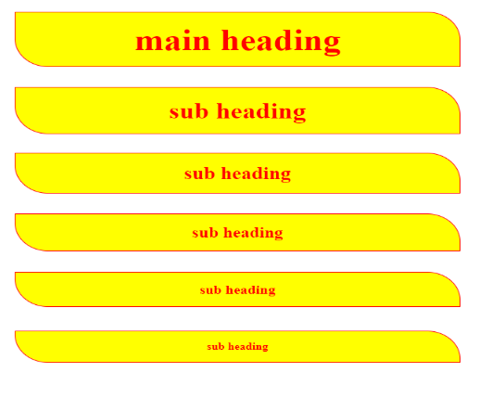

|  |  |
| --- | --- |
| <!DOCTYPE html>  <html lang="en">  <head>      <meta charset="UTF-8">      <meta name="viewport" content="width=device-width, initial-scale=1.0">      <title>div border</title>      <style>          h1{              padding: 20px;              border: 2px solid red;              color: red;              display: flex;              justify-content: center;              align-items: center;              border-radius: 0px 50px 0 50px;              background-color: yellow;          }            h2{              padding: 20px;              border: 2px solid red;              color: red;              display: flex;              justify-content: center;              align-items: center;              border-radius: 0px 50px 0 50px;              background-color: yellow;          }            h3{              padding: 20px;              border: 2px solid red;              color: red;              display: flex;              justify-content: center;              align-items: center;              border-radius: 0px 50px 0 50px;              background-color: yellow;          }            h4{              padding: 20px;              border: 2px solid red;              color: red;              display: flex;              justify-content: center;              align-items: center;              border-radius: 0px 50px 0 50px;              background-color: yellow;          } | h5{              padding: 30px;              border: 3px solid red;              color: red;              display: flex;              justify-content: left;              align-items: left;              border-radius: 0px 50px 0 50px;              background-color: yellow;          }          h6{              padding: 20px;              border: 2px solid red;              color: red;              display: flex;              justify-content: left;              align-items: center;              border-radius: 0px 50px 0 50px;              background-color: yellow;          }          </style>  </head>  <body>      <section >          <h1>main heading</h1>      </section>      <div ></div>          <h2>main heading</h2>      </div>      <div >          <h3>sub heading</h3>      </div>      <div ></div>          <h4>sub heading</h4>      </div>      <div >          <h5>sub heading</h5>      </div>      <div ></div>          <h6>sub heading</h6>      </div>  </body>  </html> |

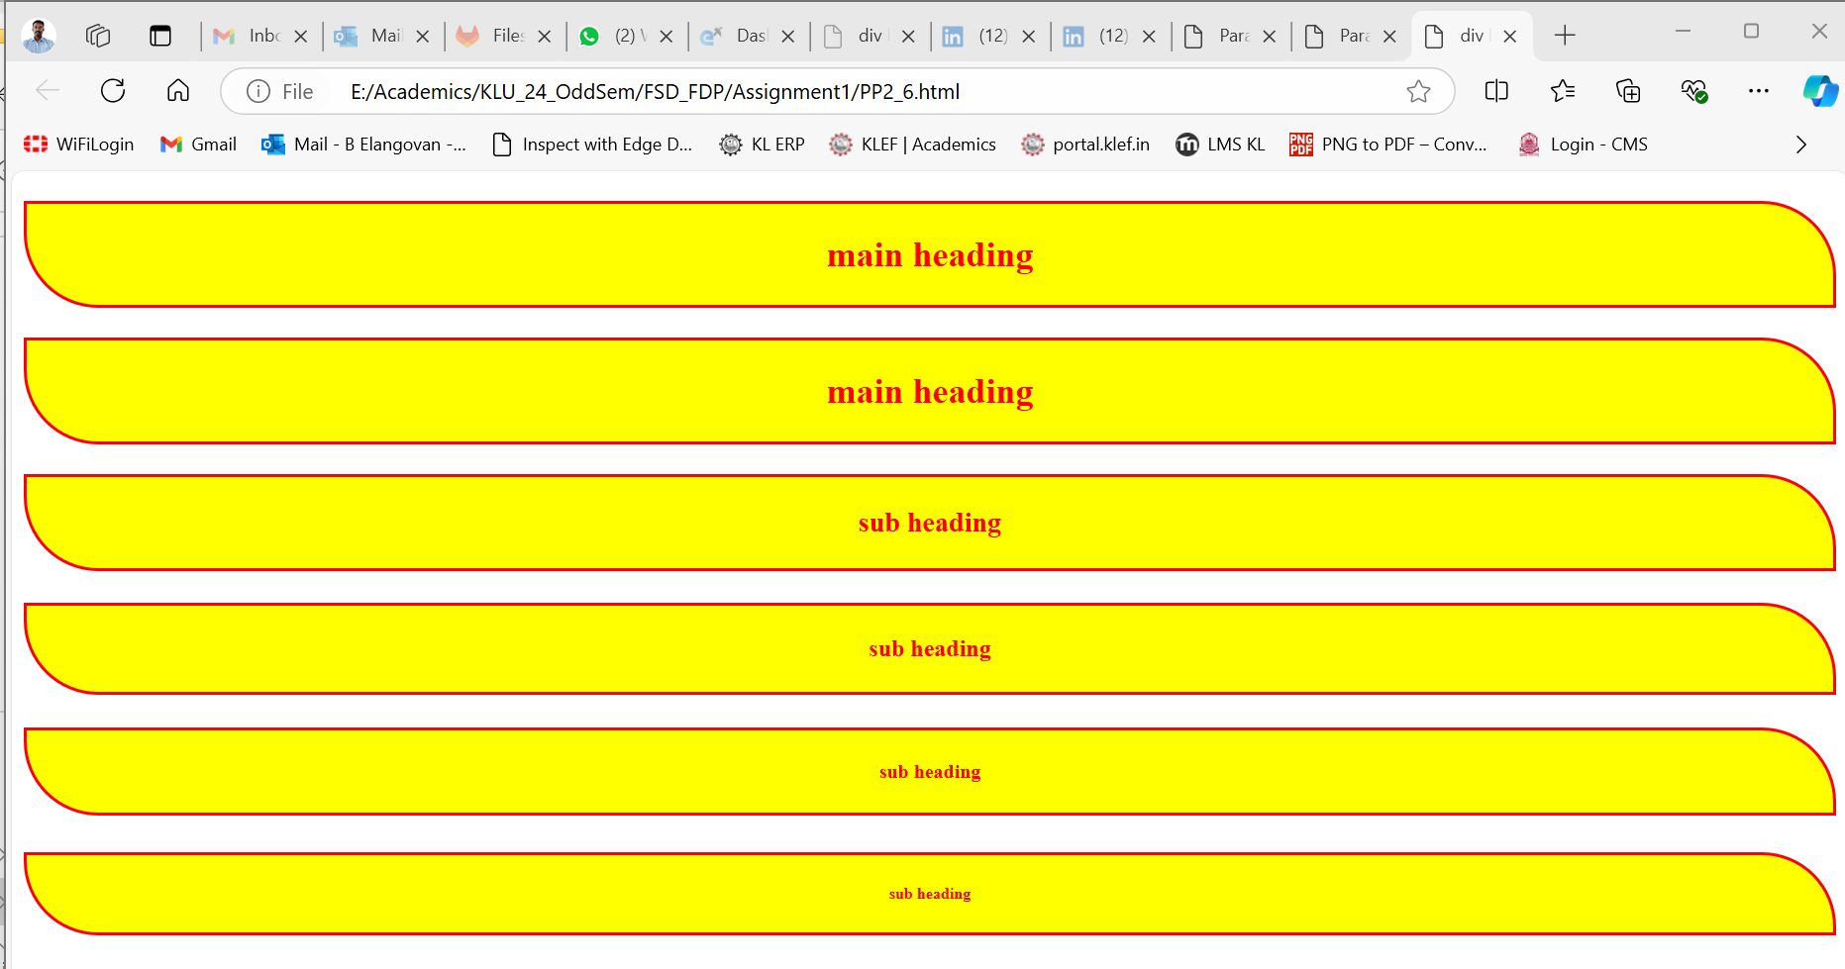

**PRACTICE PAPER-3: PARAGRAPHS**

1) which tag is used to create the Paragraphs _ <p>

2) Are Paragraphs Block Level Elements? (yes/no):yes

3) how to convert block to inline: using display: inline;

4) how to convert inline to block?: display: block;

5) complete the below application with paragraphs

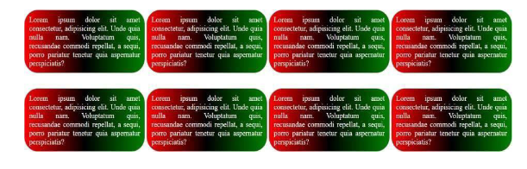

|  |  |
| --- | --- |
| <!DOCTYPE html>  <!-- BE -->  <html lang="en">  <head>      <meta charset="UTF-8">      <meta name="viewport" content="width=device-width, initial-scale=1.0">      <title>Paragraph</title>      <style>          p {              background: linear-gradient(to right, red, green, blue);              padding: 10px;              width: 300px;              border-radius: 20px;              border: 2px solid blue;              color: white;              text-align: justify;          }          .divclass {              display: flex;              flex-wrap: wrap;              gap: 10px;              padding: 10px;          }      </style>  </head>  <body>      <div class="divclass">          <p>              Lorem ipsum dolor sit amet consectetur adipisicing elit. Repellendus assumenda voluptates eum nemo repellat              ratione maxime iusto id laudantium eligendi unde libero facere cupiditate, magnam aliquid repudiandae              voluptate veritatis voluptatem.          </p> | <p>              Lorem ipsum dolor sit amet consectetur adipisicing elit. Repellendus assumenda voluptates eum nemo repellat              ratione maxime iusto id laudantium eligendi unde libero facere cupiditate, magnam aliquid repudiandae              voluptate veritatis voluptatem.          </p>          <p>              Lorem ipsum dolor sit amet consectetur adipisicing elit. Repellendus assumenda voluptates eum nemo repellat              ratione maxime iusto id laudantium eligendi unde libero facere cupiditate, magnam aliquid repudiandae              voluptate veritatis voluptatem.          </p>          <p>              Lorem ipsum dolor sit amet consectetur adipisicing elit. Repellendus assumenda voluptates eum nemo repellat              ratione maxime iusto id laudantium eligendi unde libero facere cupiditate, magnam aliquid repudiandae              voluptate veritatis voluptatem.          </p>          <p>              Lorem ipsum dolor sit amet consectetur adipisicing elit. Repellendus assumenda voluptates eum nemo repellat              ratione maxime iusto id laudantium eligendi unde libero facere cupiditate, magnam aliquid repudiandae              voluptate veritatis voluptatem.          </p>          <p>              Lorem ipsum dolor sit amet consectetur adipisicing elit. Repellendus assumenda voluptates eum nemo repellat              ratione maxime iusto id laudantium eligendi unde libero facere cupiditate, magnam aliquid repudiandae              voluptate veritatis voluptatem.          </p>      </div>  </body>  </html> |

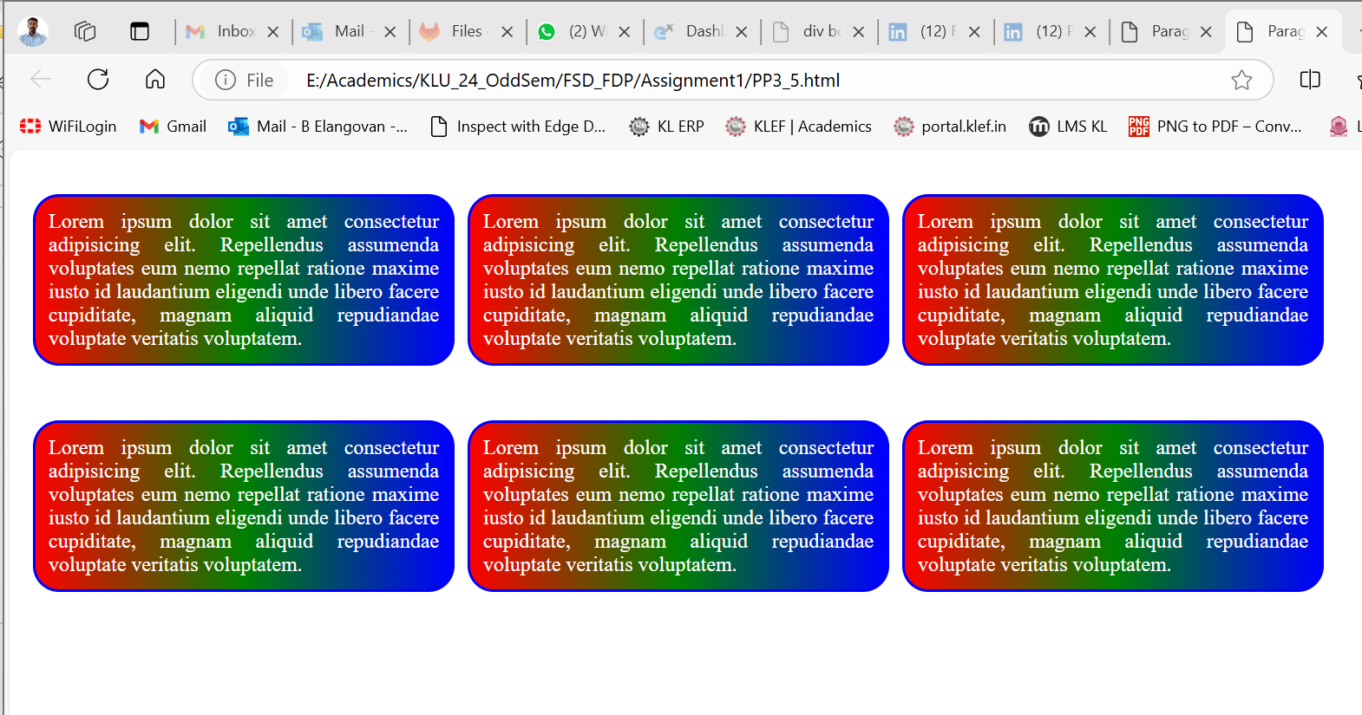

**PRACTICE PAPER-4: DIVISIONS**

1) How to apply internal styles to the web pages

Using the <style> tag within the <head> section

2) write the Differences between external CSS and Internal CSS?

External CSS:

.css file linked to the HTML

Can use in multiple HTML pages.

Easy to maintain and update across multiple pages.

Reusable

Internal CSS:

In the <style> tag inside the HTML

Only with in the page

Limited to a single HTML page

3) how to create Divisions in HTML

Using div tag

Ex: <div>…… </div>

4) Explain Selectors in CSS?

Element Selector(p,div,..)

Class Selector(.)

ID Selector(#)

Attribute Selector ([type="text"])

Universal Selector(*)

5) Class selector should start with Dot .

6) ID Selector should start with #

7) Differences Between Class selector and ID Selector?

Class: ., applied to multiple elements.

ID: #, unique and applied to a single element

8) How to create universal selector

*{….}

9) Write the code for below application

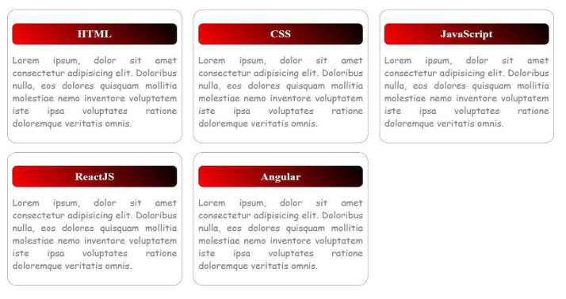

|  |  |
| --- | --- |
| <!DOCTYPE html>  <!-- BE -->  <html lang="en">  <head>      <meta charset="UTF-8">      <meta name="viewport" content="width=device-width, initial-scale=1.0">      <title>Paragraph</title>      <style>          p {              padding: 10px;              width: 300px;              border-radius: 15px;              border: 2px solid rgb(130, 130, 134);              text-align: justify;          }          .divclass {              display: flex;              flex-wrap: wrap;              gap: 10px;              padding: 10px;          }          .spanheader {              background: linear-gradient(to right, red, green);              display: inline-block;              width: 300px;              border-radius: 7px;              border: 2px solid blue;              display: flex;              color: white;              justify-content: center;            }      </style>  </head>  <body>      <div class="divclass">          <p>              <span class="spanheader">                  HTML              </span>              Lorem ipsum dolor sit amet consectetur adipisicing elit. Repellendus assumenda voluptates eum nemo repellat              ratione maxime iusto id laudantium eligendi unde libero facere cupiditate, magnam aliquid repudiandae              voluptate veritatis voluptatem.          </p> | <p>              <span class="spanheader">                  Java Script              </span>              Lorem ipsum dolor sit amet consectetur adipisicing elit. Repellendus assumenda voluptates eum nemo repellat              ratione maxime iusto id laudantium eligendi unde libero facere cupiditate, magnam aliquid repudiandae              voluptate veritatis voluptatem.          </p>          <p>    <span class="spanheader">                  CSS              </span>              Lorem ipsum dolor sit amet consectetur adipisicing elit. Repellendus assumenda voluptates eum nemo repellat              ratione maxime iusto id laudantium eligendi unde libero facere cupiditate, magnam aliquid repudiandae              voluptate veritatis voluptatem.          </p>          <p>              <span class="spanheader">                  ReactJS              </span>              Lorem ipsum dolor sit amet consectetur adipisicing elit. Repellendus assumenda voluptates eum nemo repellat              ratione maxime iusto id laudantium eligendi unde libero facere cupiditate, magnam aliquid repudiandae              voluptate veritatis voluptatem.          </p>          <p>              <span class="spanheader">                  Angular              </span>              Lorem ipsum dolor sit amet consectetur adipisicing elit. Repellendus assumenda voluptates eum nemo repellat              ratione maxime iusto id laudantium eligendi unde libero facere cupiditate, magnam aliquid repudiandae              voluptate veritatis voluptatem.          </p>          <p>              <span class="spanheader">                  Elango              </span>              Lorem ipsum dolor sit amet consectetur adipisicing elit. Repellendus assumenda voluptates eum nemo repellat              ratione maxime iusto id laudantium eligendi unde libero facere cupiditate, magnam aliquid repudiandae              voluptate veritatis voluptatem.          </p>      </div>  </body>  </html> |
|  |  |

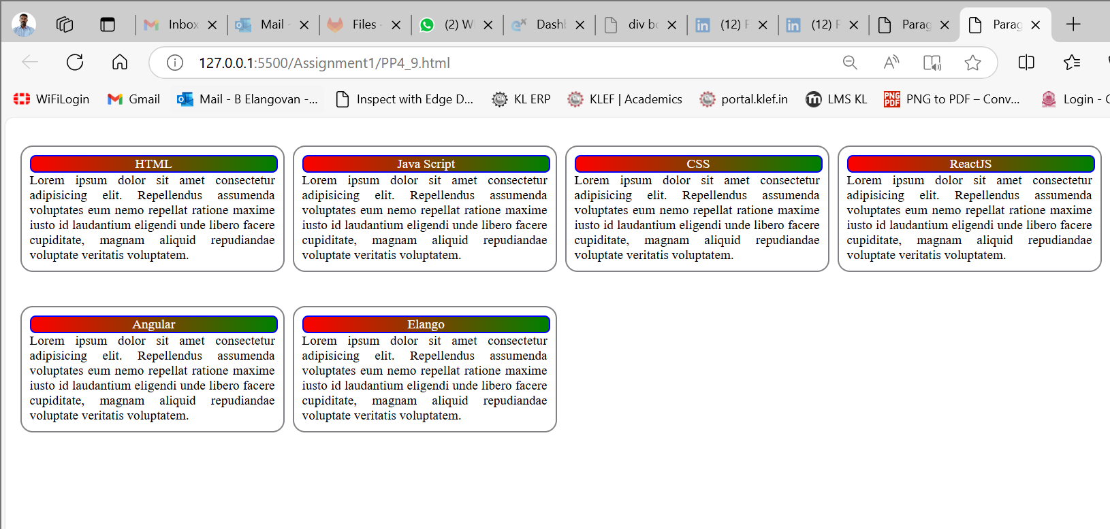

**PRACTICE PAPER-5: Buttons, span, images and Inline CSS**

1) How to Create Button and Write Basic Example

Ans:

2) Explain <span> tag in HTML?

Ans:

3) Are Button Span and img tags are inline (yes/no)

4) How to write inline CSS

5) In How Many ways we can apply CSS?

Ans:

6) Explain CSS Specificity?

Ans:

7) How to display images in HTML _

8) Is <img> tag paired tag? _

9) Write <img> tag attributes

Ans: <img src=”…” >

10) Explain hover in CSS?

element:hover { }

11) write the code for below application

<!DOCTYPE html>

<!-- BE -->

<html lang="en">

<head>

    <meta charset="UTF-8">

    <meta name="viewport" content="width=device-width, initial-scale=1.0">

    <title>Paragraph</title>

    <style>

        .divclass {

            display: inline-block;

            flex-direction: column;

            flex-wrap: wrap;

            gap: 10px;

            padding: 10px;

            border: 2px solid brown;

            border-radius: 20px;

            width: 180px;

            height: 180px;

        }

        img {

            width: 150px;

        }

    </style>

</head>

<body>

    <div class="divclass">

        <a hred="#"><img src="img1.jpg"></a>

    </div>

    <div class="divclass">

      <a hred="#">  <img src="img2.jpg"></a>

    </div>

    <div class="divclass">

        <a hred="#"><img src="img3.jpg"></a>

    </div>

</body>

</html>



**PRACTICE PAPER-6: Anchor Tag**

1) How to create Hyper Links in HTML?

Ans: <a href=”” > Element </a>

2) Write Attributes of Anchor Tag?

Ans: a, href, target, title

3) implement the below application with anchor tag

Flipkart -> https://www.flipkart.com/

Amazon -> https://www.amazon.in/

AJIO -> https://www.ajio.com/

Myntra -> https://www.myntra.com/

Load above web sites in new tab

<!DOCTYPE html>

<html lang="en">

<head>

    <meta charset="UTF-8">

    <meta name="viewport" content="width=device-width, initial-scale=1.0">

    <title>Link</title>

    <style>

        div{

            display: flex;

            justify-content: space-between;

            width: 90vw;

            gap: 10px;

            font-size: 50px;

            color: blue;

            border:2px sold red;

        }

    </style>

</head>

<body>

    <div>

        <a href="https://www.flipkart.com/">Flipkart</a>

        <a href=" https://www.amazon.in/">Amazon</a>

        <a href="https://www.ajio.com/">AJIO</a>

        <a href="https://www.myntra.com/">Myntra</a>

    </div>

</body>

</html>

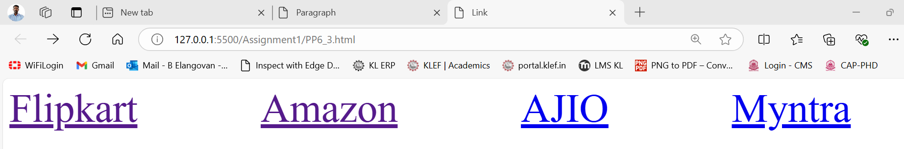

4) implement the below application with anchor tag

PRACTICE PAPER-7:

1. Design the Below Application with fieldset and legend

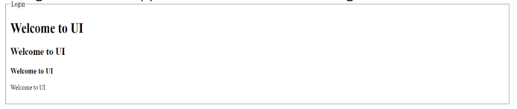

<!DOCTYPE html>

<head>

    <title>Fieldset and Legend Example</title>

    <style>

        fieldset {

            border: 2px solid #4CAF50;

            padding: 20px;

            margin: 20px;

            border-radius: 10px;

        }

        legend {

            font-weight: bold;

            color: #4CAF50;

            padding: 0 10px; /* Adds some space around the legend */

        }

        input[type="text"], input[type="email"] {

            display: block;

            margin: 10px 0;

            padding: 5px;

            width: 100%;

            max-width: 400px;

        }

    </style>

</head>

<body>

    <form>

        <fieldset>

            <legend>Login</legend>

           <h1>Welcome to UI</h1>

           <h2>Welcome to UI</h2>

           <h3>Welcome to UI</h3>

           <h4>Welcome to UI</h4>

        </fieldset>

    </form>

</body>

</html>

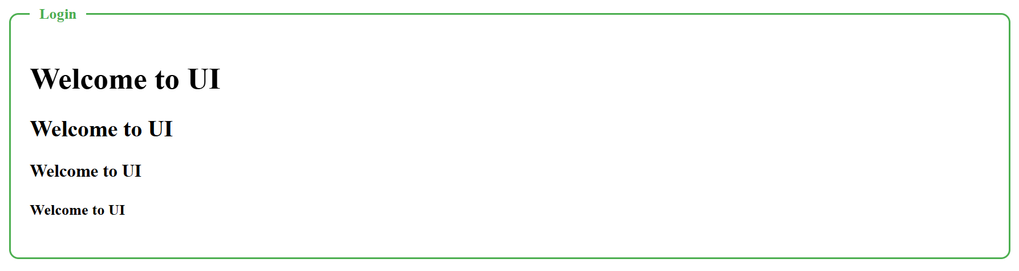

**PRACTICE PAPER-8: TABLES**

1) which tag used to create tables

<table>……</table>

2) write the tags to create tables with diagram

Ans

3) write table attributes with explanation

Th, td, tr, colspan, rowspan,

4) write the code for below diagram in practice paper and execute in laptop

|  |  |
| --- | --- |
| <!DOCTYPE html>  <html lang="en">  <head>      <meta charset="UTF-8">      <meta name="viewport" content="width=device-width, initial-scale=1.0">      <title>Product Table</title>      <style>          table {              width: 50%;              cellpadding:20px;              cellspacing :5px;              border: 2px solid black;              border-spacing: 10px;              margin: 20px 0;              text-align: center;          }        </style>  </head>  <body>        <table border="1">          <tr>              <th>SNO</th>              <th>P_ID</th>              <th>P_NAME</th>              <th>P_COST</th>          </tr>          <tr>              <td>1</td>              <td>P101</td>              <td>P_ONE</td>              <td>10000</td>          </tr> | <tr>              <td>2</td>              <td>P102</td>              <td>P_TWO</td>              <td>20000</td>          </tr>          <tr>              <td>3</td>              <td>P103</td>              <td>P_THREE</td>              <td>30000</td>          </tr>          <tr>              <td>4</td>              <td>P104</td>              <td>P_FOUR</td>              <td>40000</td>          </tr>          <tr>              <td>5</td>              <td>P105</td>              <td>P_FIVE</td>              <td>50000</td>          </tr>      </table>  </body>  </html> |

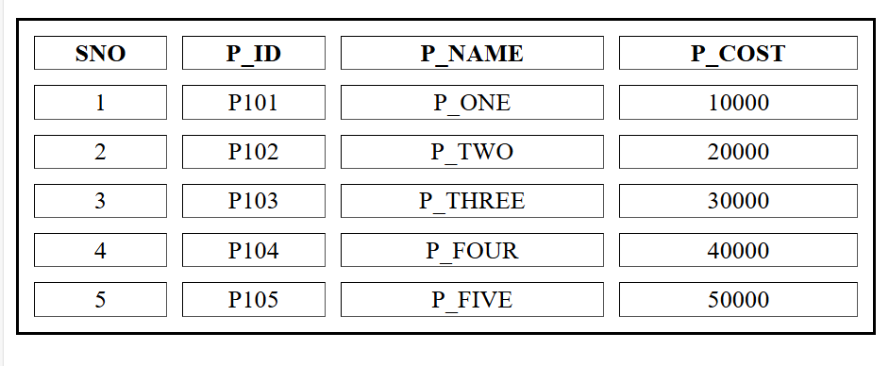

5) write the code for below diagram in practice paper and execute in laptop

|  |  |
| --- | --- |
| <!DOCTYPE html>  <head>    <title>College Time Table</title>    <style>      table {        width: 100%;        border-collapse: collapse;        text-align: center;        font-family: Arial, sans-serif;      }      th, td {        border: 1px solid black;        padding: 10px;      }      th {        background-color: #f4f4f4;      }      .subject {        font-weight: bold;      }      .blue { color: blue; }      .orange { color: orange; }      .purple { color: purple; }      .green { color: green; }      .red { color: red; }      .bold { font-weight: bold; }      </style>  </head>  <body>  <h1 style="text-align: center;">COLLEGE TIME TABLE</h1>  <table>    <thead>      <tr>        <th></th>        <th>8:30-9:30</th>        <th>9:30-10:30</th>        <th>10:30-11:30</th>        <th>11:30-12:30</th>        <th>12:30-2:00</th>        <th>2:00-3:00</th>        <th>3:00-4:00</th>        <th>4:00-5:00</th>      </tr>    </thead>    <tbody>      <tr>        <th>MONDAY</th>        <td>---</td>        <td class="subject blue">SUB1</td>        <td class="subject orange">SUB2</td>        <td class="subject purple">SUB3</td>        <td class="lunch" rowspan="6">L<br>U<br>N<br>C<br>H</td>        <td class="subject green">SUB4</td>        <td class="subject red">SUB5</td>        <td class="bold">COUNSELLING CLASS</td>      </tr> | <tr>        <th>TUESDAY</th>        <td class="subject blue">SUB1</td>        <td class="subject orange">SUB2</td>        <td class="subject purple">SUB3</td>        <td>---</td>        <td class="subject orange">SUB2</td>        <td class="subject orange">SUB2</td>        <td>LIBRARY</td>      </tr>      <tr>        <th>WEDNESDAY</th>        <td class="subject blue">SUB1</td>        <td class="subject orange">SUB2</td>        <td class="subject red">SWA</td>        <td>---</td>        <td class="bold" colspan="3">LAB</td>        </tr>      <tr>        <th>THURSDAY</th>        <td class="subject blue">SUB1</td>        <td class="subject orange">SUB2</td>        <td class="subject purple">SUB3</td>        <td>---</td>        <td class="subject green">SUB4</td>        <td class="subject red">SUB5</td>        <td>LIBRARY</td>      </tr>      <tr>        <th>FRIDAY</th>        <td class="subject blue">SUB1</td>        <td class="subject orange">SUB2</td>        <td class="subject purple">SUB3</td>        <td>---</td>        <td class="subject green">SUB4</td>        <td class="subject red">SUB5</td>        <td>LIBRARY</td>      </tr>      <tr>        <th>SATURDAY</th>        <td class="subject blue">SUB1</td>        <td colspan="3" class="bold">SEMINAR</td>        <td class="subject green">SUB4</td>        <td class="subject red">SUB5</td>        <td>LIBRARY</td>      </tr>    </tbody>  </table>  </body>  </html> |

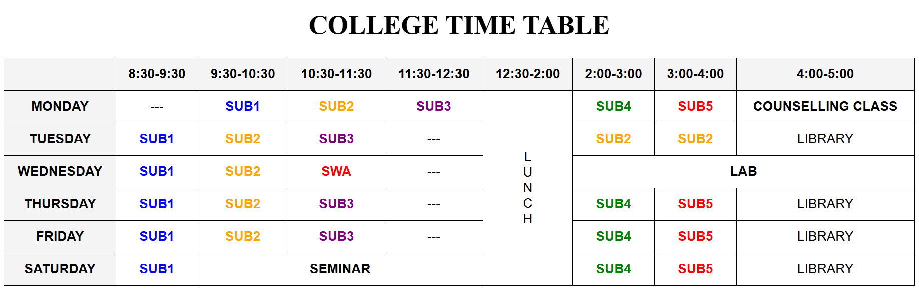

6) write the code for below diagram in practice paper and execute in laptop

<!DOCTYPE html>

<head>

  <style>

    table {

      width: 50%;

      border: 2px solid black;

      border-spacing: 3px;

      margin: 20px auto;

      font-family: Arial, sans-serif;

    }

    th, td {

      border: 2px solid black;

      padding: 10px;

      text-align: center;

    }

    th {

      background-color: #f4f4f4;

    }

    h1 {

      text-align: center;

      font-family: Arial, sans-serif;

    }

  </style>

</head>

<body>

<table>

  <tr>

    <th>Columu 1</th>

    <th>Columu 2</th>

    <th>Columu 3</th>

  </tr>

  <tr>

    <td rowspan="2">Row 1 Cell 1</td>

    <td>Row 1 Cell 2</td>

    <td>Row 1 Cell 3</td>

  </tr>

  <tr>

    <td>Row 2 Cell 2</td>

    <td>Row 2 Cell 3</td>

  </tr>

  <tr>

    <td colspan="3" style="text-align: left;">Row 3 Cell 1</td>

  </tr>

</table>

</body>

</html>

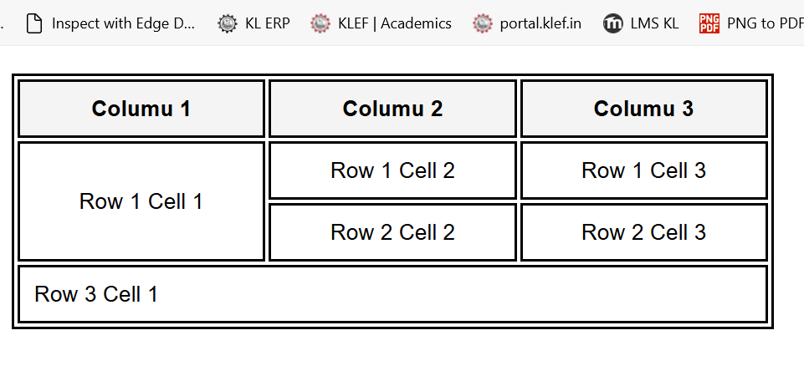

7) write the code for below diagram in practice paper and execute in laptop

<!DOCTYPE html>

<head>

  <style>

    table {

      width: 100%;

     border-spacing: 5px;

      text-align: center;

      font-family: Arial, sans-serif;

    }

    td {

      border: 1px solid black;

      padding: 10px;

    }

  </style>

</head>

<body>

  <h1 style="text-align: center;">COLLEGE TIME TABLE</h1>

  <table border="1">

      <tr>

        <td rowspan="3">Day</td>

        <td colspan="3">Seminar</td>

      </tr>

      <tr>

        <td colspan="2">Schedule</td>

        <td rowspan="2">Topic</td>

      </tr>

      <tr>

        <td>begin</td>

        <td>End</td>

      </tr>

      <tr>

        <td rowspan="2">Monday</td>

        <td rowspan="2">8.00 am</td>

        <td rowspan="2">5.00 pm</td>

        <td> Introduction to</td>

      </tr>

      <tr>

        <td>Validity</td>

      </tr>

      <tr>

        <td rowspan="3">Tuesday</td>

        <td>8.00 am</td>

        <td>11.00 am</td>

        <td rowspan="2">X path</td>

      </tr>

      <tr>

        <td>11.00 am</td>

        <td>2.00 pm</td>

      </tr>

      <tr>

        <td>2.00 pm</td>

        <td>5.00 pm</td>

        <td>XSL Trans</td>

      </tr>

      <tr>

        <td>Wednesday</td>

        <td>8.00 am</td>

        <td>12.00 pm</td>

        <td>XSL Formatting</td>

      </tr>

  </table>

</body>

</html>

8) write the code for below diagram in practice paper and execute in laptop

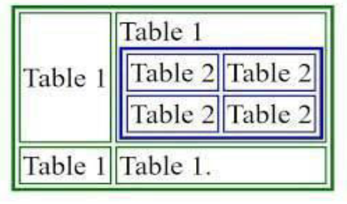

<!DOCTYPE html>

<head>

  <style>

    table {

      width: 250px;

      border-spacing: 2px;

      text-align: center;

      font-family: Arial, sans-serif;

      border: 2px solid green;

    }

  </style>

</head>

<body>

  <table border="1">

    <tr>

      <td rowspan="2">Table1</td>

      <td>Table1</td>

    </tr>

    <tr>

      <td>

        <table border="1" style="border: 2px solid blue;">

          <tr>

            <td>Table2</td><td>Table2</td>

          </tr>

          <tr>

            <td>Table2</td><td>Table2</td>

          </tr>

        </table>

      </td>

    </tr>

    <tr>

      <td>Table1</td>

      <td>Table1</td>

    </tr>

  </table>

</body>

</html>

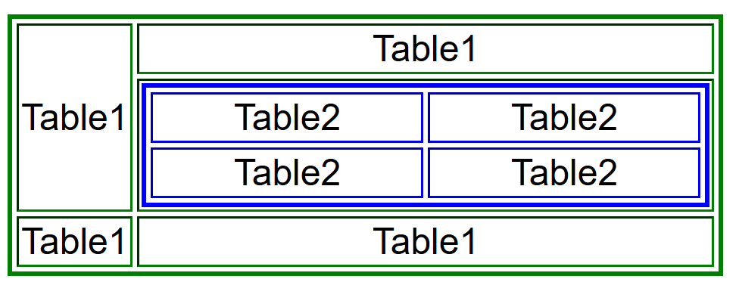

9) write the code for below diagram in practice paper and execute in laptop

<!DOCTYPE html>

<head>

  <style>

    table {

      width: 250px;

     border-spacing: 5px;

      text-align: center;

      font-family: Arial, sans-serif;

    }

    td {

      border: 1px solid black;

      padding: 10px;

    }

  </style>

</head>

<body>

  <table border="1" width="250px">

    <tr style="background-color: black;color: white; text-align: right;">

      <td colspan="4" style="width: 20px; height: 20px;">0</td>

  </tr>

  <tr style="background-color: rgb(207, 200, 200);">

      <td>+</td>

      <td>-</td>

      <td>*</td>

      <td>/</td>

  </tr>

  <tr>

      <td>7</td>

      <td>8</td>

      <td>9</td>

      <td rowspan="4" style="background-color: orange;">=</td>

  </tr>

  <tr>

      <td>4</td>

      <td>5</td>

      <td>6</td>

  </tr>

  <tr>

      <td>1</td>

      <td>2</td>

      <td>3</td>

  </tr>

  <tr>

      <td>0</td>

      <td>.</td>

      <td style="font-size: small;">AC</td>

  </tr>

      </table>

  </body>

  </html>

  </table>

</body>

</html>

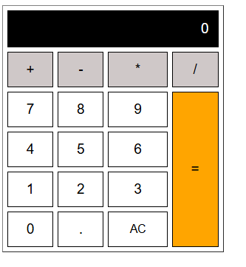

10) write the code for below diagram in practice paper and execute in laptop

<!DOCTYPE html>

<head>

  <link rel="stylesheet" href="https://cdnjs.cloudflare.com/ajax/libs/font-awesome/4.7.0/css/font-awesome.min.css">

  <style>

    table {

      width: 450px;

      text-align: center;

      font-family: Arial, sans-serif;

      border: 1px solid black;

    }

    .bgpink{

      background-color: rgb(234, 83, 216);

    }

    .bgbrown{

      background-color: rgb(231, 114, 114);

    }

    .whitefont{

      color:white;

    }

  </style>

</head>

<body>

  <table>

    <tr class="bgpink whitefont">

      <td>Slno</td>

      <td>Name</td>

      <td>COST</td>

      <td>UPDATE</td>

      <td>DELETE</td>

    </tr>

    <tr class="bgbrown">

      <td>1</td>

      <td>LAPTOP</td>

      <td><i class="fa fa-rupee"></i> 5000</td>

      <td><i class="fa fa-edit"></i></td>

      <td><i class="fa fa-trash"></i></td>

    </tr>

    <tr class="bgpink whitefont">

      <td>2</td>

      <td>Mobile</td>

      <td>50</td>

      <td><i class="fa fa-edit"></i></td>

      <td><i class="fa fa-trash"></i></td>

    </tr>

    <tr class="bgbrown">

      <td>3</td>

      <td>shoes</td>

      <td>10</td>

      <td><i class="fa fa-edit"></i></td>

      <td><i class="fa fa-trash"></i></td>

    </tr>

  </table>

</body>

</html>

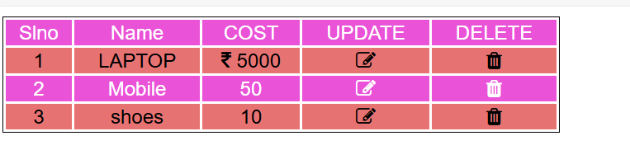

11) write few points related to font-awesome

It is an Icon library, various variety of icon in diff categories are available. Its responsive and scalable.

Its available for free and paid both

12) cart symbol’: class="fa fa-shopping-cart"

13) trash symbol : class="fa fa-trash"

14) edit symbol : class="fa fa-edit"

15) rupee symbol : class="fa fa-rupee"

16) dollar symbol : class="fa fa-dollar"

17) user profile : class="fa fa-user"

18) how to use font-awesome

Include the CDN link in the html document

Use the class as per the need to design the page.

19) CDN Stands for Content Delivery Network

20) is Font Awesome CSS library? Yes

**Practice Paper- Lists**

1) Types of Lists in HTML?

1) ordered list

2) unordered list

3) definition list

2) Write the Syntax for Ordered List?

<ol>

<li></li>

--

--

--

</ol>

3) Write the Attributes of Ordered List?

1) type="A"/"a"/"I"/"i"/1

default is the number

2) start="5"

list starts with specified number

3) reversed

it is used to reverse the list item numbers

4) Write the Syntax for Unordered List?

<ul>

<li></li>

--

--

--

</ul>

5) Write the Unordered List Attributes?

type="disc"/"square"/"circle"

default symbol is "**disc**"

6) Write the Syntax for Definition List

<dl>

<dt></dt>

<dd></dd>

<dd></dd>

--

--

<dt></dt>

<dd></dd>

<dd></dd>

--

--

</dl>

7) <dt></dt> stands for definition term

8) <dd></dd> stands for definition description

9) <li></li> stands for list item

10) <dl></dl> stands for definition list

11) Write the code for below application and execute in laptop

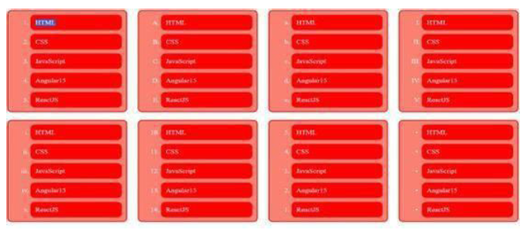

**list.html**

<!DOCTYPE html>

<html>

<head>

<title>Ordered List</title>

<link rel="stylesheet" href="lists.css">

</head>

<body>

<ol>

<li>HTML</li>

<li>CSS</li>

<li>JAVASCRIPT</li>

<li>ANGULAR 15</li>

<li>REACTJS</li>

</ol>

<ol>

    <li>HTML</li>

    <li>CSS</li>

    <li>JAVASCRIPT</li>

    <li>ANGULAR 15</li>

    <li>REACTJS</li>

    </ol>

<ol>

    <li>HTML</li>

    <li>CSS</li>

    <li>JAVASCRIPT</li>

    <li>ANGULAR 15</li>

    <li>REACTJS</li>

    </ol>

<ol type="A">

<li>HTML</li>

<li>CSS</li>

<li>JAVASCRIPT</li>

<li>ANGULAR 15</li>

<li>REACTJS</li>

</ol>

<ol type="a">

<li>HTML</li>

<li>CSS</li>

<li>JAVASCRIPT</li>

<li>ANGULAR 15</li>

<li>REACTJS</li>

</ol>

<ol type="I">

<li>HTML</li>

<li>CSS</li>

<li>JAVASCRIPT</li>

<li>ANGULAR 15</li>

<li>REACTJS</li>

</ol>

<ol type="i">

<li>HTML</li>

<li>CSS</li>

<li>JAVASCRIPT</li>

<li>ANGULAR 15</li>

<li>REACTJS</li>

</ol>

<ol start="5" reversed>

    <li>HTML</li>

<li>CSS</li>

<li>JAVASCRIPT</li>

<li>ANGULAR 15</li>

<li>REACTJS</li>

</ol>

</body>

</html>

**lists.css**

ol, ul {

    background-color: orangered;

    width: 15%;

    display: inline-block;

    margin: 20px;

    border: 2px solid orange;

    border-radius: 20px;

    }

    li {

    color: white;

    background-color: orangered;

    margin: 10px;

    padding: 10px;

    border: 2px solid orange;

    border-radius: 20px;

    }

12) Write the code for below application and execute in laptop

<!DOCTYPE html>

<html lang="en">

<head>

<meta charset="UTF-8">

<meta name="viewport" content="width=device-width, initial-scale=1.0">

<title>Quiz</title>

</head>

<body>

<h1>Quiz</h1>

<ol>

<li>HTML is an ________?

<ul>

<li>Markup language</li>

<li>Programming language</li>

<li>None of these</li>

</ul>

</li>

<li>CSS is used for

<ul>

<li>Styling</li>

<li>Scripting</li>

<li>None of these</li>

</ul>

</li>

<li>Which of the following is dynamic from of HTML?

<ul>

<li>XML</li>

<li>DHTML</li>

<li>None of these</li>

</ul>

</li>

<li>Which of the following can be linked with HTML and CSS?

<ul>

<li>JavaScript</li>

<li>C++</li>

<li>None of these</li>

</ul>

</li>

</ol>

</body>

</html>

13) Write the code for below application and execute in laptop

<!DOCTYPE html>

<html lang="en">

<head>

<meta charset="UTF-8">

<meta name="viewport" content="width=device-width, initial-scale=1.0">

<title>Nested Lists</title>

</head>

<body>

<h2>Preceding Text</h2>

<ol type="I">

<li>List Item 1

<ol type="a">

<li>Nested Item 1.1</li>

<li>Nested Item 1.2</li>

</ol>

</li>

<li>List Item 2

<ol type="1">

<li>Nested Item 2.1</li>

<li>Nested Item 2.2

<ul>

<li>Nested Item 2.2.1</li>

<li>Nested Item 2.2.2

<ul>

<li>Nested Item 2.2.2.1</li>

<li>Nested Item 2.2.2.2</li>

</ul>

</li>

<li>Nested Item 2.2.3</li>

</ul>

</li>

<li>Nested Item 2.3</li>

</ol>

</li>

<li>List Item 3

<ul>

<li>Nested Item 3.1</li>

<li>Nested Item 3.1</li>

<li>Nested Item 3.1</li>

</ul>

</li>

</ol>

</body>

</html>

14) Write the code for below application and execute in laptop



<!DOCTYPE html>

<html lang="en">

<head>

<meta charset="UTF-8">

<meta name="viewport" content="width=device-width, initial-scale=1.0">

<title>Styled Lists</title>

<style>

body {

font-family: Arial, sans-serif;

}

.container {

margin: 20px;

}

.section {

margin-bottom: 20px;

}

.section h2 {

background-color: #FF6347;

color: white;

padding: 10px;

margin: 0;

text-align: center;

}

.section ul {

list-style: none;

padding: 0;

margin: 0;

}

.section ul li {

padding: 10px;

border-bottom: 1px solid black;

}

</style>

</head>

<body>

<div class="container">

<div class="section">

<h2>A</h2>

<ul>

<li>Hello_1</li>

<li>Hello_2</li>

<li>Hello_3</li>

<li>Hello_4</li>

<li>Hello_5</li>

</ul>

</div>

<div class="section">

<h2>B</h2>

<ul>

<li>Hello_1</li>

<li>Hello_2</li>

<li>Hello_3</li>

<li>Hello_4</li>

<li>Hello_5</li>

</ul>

</div>

<div class="section">

<h2>C</h2>

<ul>

<li>Hello_1</li>

<li>Hello_2</li>

<li>Hello_3</li>

<li>Hello_4</li>

<li>Hello_5</li>

</ul>

</div>

<div class="section">

<h2>D</h2>

<ul>

<li>Hello_1</li>

<li>Hello_2</li>

<li>Hello_3</li>

<li>Hello_4</li>

</ul>

</div>

</div>

</body>

</html>

**Practice Paper- Forms**

1. How to create Forms in HTML

To create forms in HTML, we use the <form> element, which defines a container for user input. Inside this container, we can place various form elements like text fields, radio buttons, checkboxes, and submit buttons.

1. Write form attributes

HTML form elements can have various attributes to define their behavior, appearance and functionality. Below are the most common form-related attributes and their descriptions:

**<form> Element Attributes**

| **Attribute** | **Description** |
| --- | --- |
| action | Specifies the URL to which the form data will be submitted. |
| method | Defines how the form data is sent to the server. Possible values: GET or POST. |
| enctype | Specifies the encoding type for the form when submitting file uploads. Default is application/x-www-form-urlencoded. To upload files, use multipart/form-data. |
| target | Specifies where to display the response after form submission. Example: _blank to open in a new tab. |
| autocomplete | Specifies whether the form should have autocomplete enabled. Possible values: on or off. |
| novalidate | If present, the form will not validate its inputs before submission. |
| name | Assigns a name to the form. Useful for JavaScript or server-side referencing. |
| rel | Specifies the relationship between the current document and the linked document when the target is set (used with target="_blank"). |

Like above there are various attributes for input, textarea, select and button elements, apart from that there certain common attributes for all form elements.

3) Why placeholder attribute in <input></input> tag

The placeholder attribute in an <input> tag is used to provide a short, descriptive text inside the input field. This text serves as a hint to the user about what type of information or data is expected in that particular field. Once the user starts typing, the placeholder text disappears.

4) How to create dropdown in Forms write basic example

To create a dropdown menu in an HTML form, we use the <select> element along with <option> elements inside it. The <select> element represents the dropdown, and the <option> elements represent the selectable items within the dropdown.

<!DOCTYPE html>

<html lang="en">

<head>

<meta charset="UTF-8">

<meta name="viewport" content="width=device-width, initial-scale=1.0">

<title>Dropdown Example</title>

</head>

<body>

<h2>Select Your Country</h2>

<form action="/submit_form" method="POST">

<label for="country">Choose a country:</label>

<select id="country" name="country">

<option value="usa">USA</option>

<option value="canada">Canada</option>

<option value="uk">United Kingdom</option>

<option value="australia">Australia</option>

</select>

<br><br>

<input type="submit" value="Submit">

</form>

</body>

</html>

5) How to create address field in HTML Forms

To create an address field in an HTML form, you can use a combination of input fields like text, postal code and country dropdowns. An address typically includes fields for the street, city, state, postal code (ZIP code) and country. You can structure these using the <input> tag for text fields and <select> for dropdowns.

6) Single selection controls called as

Single selection controls in HTML are typically referred to as **radio buttons**.

7) Multi selection controls called as

Multi-selection controls in HTML are typically referred to as **checkboxes** or **multi-select dropdowns**.

8)Implement the below form

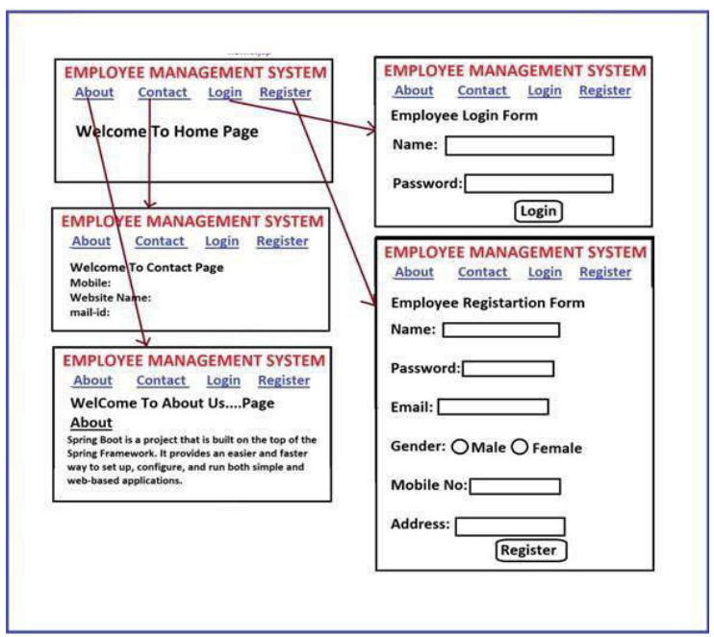

<!DOCTYPE html>

<html lang="en">

<head>

    <meta charset="UTF-8">

    <meta name="viewport" content="width=device-width, initial-scale=1.0">

    <title>Employee Management System</title>

    <style>

        body {

            font-family: Arial, sans-serif;

        }

        nav a {

            margin-right: 15px;

            text-decoration: none;

            color: blue;

        }

        .container {

            border: 1px solid #000;

            padding: 20px;

            margin: 20px auto;

            width: 300px;

        }

        h2 {

            text-align: center;

        }

        form {

            margin-top: 10px;

        }

        label, input, select, textarea {

            display: block;

            width: 100%;

            margin-bottom: 10px;

        }

        input[type="submit"] {

            width: auto;

        }

        .gender {

            display: flex;

            justify-content: space-around;

        }

    </style>

</head>

<body>

    <!-- Navigation Links -->

    <nav>

        <a href="#home">About</a>

        <a href="#contact">Contact</a>

        <a href="#login">Login</a>

        <a href="#register">Register</a>

    </nav>

    <!-- Home Page -->

    <div id="home" class="container">

        <h2>Employee Management System</h2>

        <p>Welcome to Home Page</p>

    </div>

    <!-- Contact Page -->

    <div id="contact" class="container">

        <h2>Employee Management System</h2>

        <p>Welcome to Contact Page</p>

        <form>

            <label for="mobile">Mobile:</label>

            <input type="text" id="mobile" name="mobile">

            <label for="website">Website Name:</label>

            <input type="text" id="website" name="website">

            <label for="email">Mail ID:</label>

            <input type="email" id="email" name="email">

        </form>

    </div>

    <!-- About Us Page -->

    <div id="about" class="container">

        <h2>Employee Management System</h2>

        <p>Welcome to About Us Page</p>

        <p>About</p>

        <p>Spring Boot is a project that is built on top of the Spring Framework. It provides an easier and faster way to set up, configure, and run both simple and web-based applications.</p>

    </div>

    <!-- Login Page -->

    <div id="login" class="container">

        <h2>Employee Management System</h2>

        <form>

            <label for="name">Name:</label>

            <input type="text" id="name" name="name" required>

            <label for="password">Password:</label>

            <input type="password" id="password" name="password" required>

            <input type="submit" value="Login">

        </form>

    </div>

    <!-- Registration Page -->

    <div id="register" class="container">

        <h2>Employee Management System</h2>

        <form>

            <label for="reg-name">Name:</label>

            <input type="text" id="reg-name" name="reg-name" required>

            <label for="reg-password">Password:</label>

            <input type="password" id="reg-password" name="reg-password" required>

            <label for="email">Email:</label>

            <input type="email" id="email" name="email" required>

            <label>Gender:</label>

            <div class="gender">

                <input type="radio" id="male" name="gender" value="male">

                <label for="male">Male</label>

                <input type="radio" id="female" name="gender" value="female">

                <label for="female">Female</label>

            </div>

            <label for="mobile">Mobile No.:</label>

            <input type="text" id="mobile" name="mobile">

            <label for="address">Address:</label>

            <textarea id="address" name="address" rows="3"></textarea>

            <input type="submit" value="Register">

        </form>

    </div>

</body>

</html>

9)implement the below form

<!DOCTYPE html>

<html lang="en">

<head>

<meta charset="UTF-8">

<meta name="viewport" content="width=device-width, initial-scale=1.0">

<title>Registration Form</title>

<style>

body {

font-family: Arial, sans-serif;

}

.form-container {

width: 300px;

margin: 0 auto;

padding: 20px;

border: 1px solid #ccc;

}

h2 {

text-align: center;

}

label, input {

display: block;

margin-bottom: 10px;

width: 100%;

}

input[type="text"], input[type="password"] {

padding: 5px;

}

input[type="submit"] {

margin-top: 10px;

padding: 5px 10px;

width: auto;

}

</style>

</head>

<body>

<div class="form-container">

<h2>Fill below form to register</h2>

<form action="/register" method="POST">

<label for="id">Enter your Id:</label>

<input type="text" id="id" name="id" required>

<label for="name">Enter your name:</label>

<input type="text" id="name" name="name" required>

<label for="password">Enter your Password:</label>

<input type="password" id="password" name="password" required>

<input type="submit" value="Register">

</form>

</div>

</body>

</html>

10)implement the below form

<!DOCTYPE html>

<html lang="en">

<head>

<meta charset="UTF-8">

<meta name="viewport" content="width=device-width, initial-scale=1.0">

<title>Customer login Form</title>

<style>

body {

font-family: Arial, sans-serif;

}

.form-container {

width: 300px;

margin: 0 auto;

padding: 20px;

border: 1px solid #ccc;

}

h2 {

text-align: center;

}

label, input {

display: block;

margin-bottom: 10px;

width: 100%;

}

input[type="text"], input[type="password"] {

padding: 5px;

}

input[type="submit"] {

margin-top: 10px;

padding: 5px 10px;

width: auto;

}

</style>

</head>

<body>

<div class="form-container">

<h2>CUSTOMER LOGIN FORM</h2>

<form action="/register" method="POST">

<label for="name">Enter your name:</label>

<input type="text" id="name" name="name" required>

<label for="password">Enter your Password:</label>

<input type="password" id="password" name="password" required>

<input type="submit" value="lOGIN">

</form>

</div>

</body>

</html>

11)Write html code for below text box?



<!DOCTYPE html>

<html lang="en">

<head>

    <meta charset="UTF-8">

    <meta name="viewport" content="width=device-width, initial-scale=1.0">

    <title>Styled Input Box</title>

    <style>

        label {

            font-weight: bold;

            color: #800000; /* Dark red color */

            font-size: 18px;

            margin-right: 10px;

        }

        input[type="text"] {

            border: 2px solid red; /* Red border */

            padding: 5px;

            color: #A0522D; /* Brown color for placeholder text */

        }

        input[type="text"]::placeholder {

            color: #A0522D; /* Placeholder color */

        }

    </style>

</head>

<body>

    <form>

        <label for="username">User Name</label>

        <input type="text" id="username" name="username" placeholder="User Name">

    </form>

</body>

</html>

Code is same like previous one, we need to remove placeholder

    <form>

        <label for="username">User Name</label>

        <input type="text" id="username" name="username" placeholder="User Name">

    </form>

<!DOCTYPE html>

<html lang="en">

<head>

<meta charset="UTF-8">

<meta name="viewport" content="width=device-width, initial-scale=1.0">

<title>Styled Password Input</title>

<style>

label {

font-weight: bold;

color: #800000; /* Dark red color */

font-size: 18px;

margin-right: 10px;

}

input[type="password"] {

border: 2px solid red; /* Red border */

padding: 5px;

color: blue; /* Blue dots for password characters */

}

</style>

</head>

<body>

<form>

<label for="password">Password</label>

<input type="password" id="password" name="password">

</form>

</body>

</html>

<!DOCTYPE html>

<html lang="en">

<head>

    <meta charset="UTF-8">

    <meta name="viewport" content="width=device-width, initial-scale=1.0">

    <title>Company Name Dropdown</title>

    <style>

        label {

            font-weight: bold;

            font-size: 18px;

            margin-right: 10px;

        }

        select {

            padding: 5px;

            font-size: 16px;

            width: 200px;

        }

        input[type="text"] {

            border: 1px solid #000; /* Black border */

            padding: 5px;

            font-size: 16px;

            width: 200px;

        }

    </style>

</head>

<body>

    <label for="companyName">Company Name:</label>

    <input type="text" id="companyName" name="companyName" onkeyup="filterFunction()" placeholder="Type to search...">

    <select id="companyList" size="4" style="display:none;">

        <option value="Tech Mahindra">Tech Mahindra</option>

        <option value="Tech Sathya">Tech Sathya</option>

        <option value="Tech Anand">Tech Anand</option>

    </select>

    <script>

        function filterFunction() {

            const input = document.getElementById('companyName');

            const filter = input.value.toLowerCase();

            const select = document.getElementById('companyList');

            const options = select.options;

            select.style.display = 'none'; // Hide dropdown initially

            let matchFound = false;

            for (let i = 0; i < options.length; i++) {

                if (options[i].value.toLowerCase().includes(filter)) {

                    options[i].style.display = 'block';

                    matchFound = true;

                } else {

                    options[i].style.display = 'none';

                }

            }

            // If there are matches, show the dropdown

            if (matchFound) {

                select.style.display = 'block';

            }

        }

        document.getElementById('companyName').addEventListener('focus', function() {

            document.getElementById('companyList').style.display = 'block';

        });

        document.getElementById('companyName').addEventListener('blur', function() {

            setTimeout(() => {

                document.getElementById('companyList').style.display = 'none';

            }, 100);

        });

    </script>

</body>

</html>

15) Write code for following output

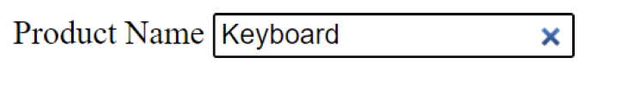

<!DOCTYPE html>

<html lang="en">

<head>

    <meta charset="UTF-8">

    <meta name="viewport" content="width=device-width, initial-scale=1.0">

    <title>Textbox with Custom Clear Button</title>

    <style>

        .textbox-container {

            position: relative;

            width: 250px;

        }

        .textbox-container input[type="text"] {

            width: 100%;

            padding-right: 30px;

            height: 30px;

            border: 1px solid #ccc;

            border-radius: 5px;

        }

        .clear-button {

            position: absolute;

            right: 10px;

            top: 50%;

            transform: translateY(-50%);

            cursor: pointer;

            font-size: 16px;

            color: #888;

            visibility: hidden;

        }

        .textbox-container input[type="text"]:not(:placeholder-shown) + .clear-button {

            visibility: visible;

        }

        .clear-button:hover {

            color: red;

        }

    </style>

</head>

<body>

<div class="textbox-container">

   Product Name: <input type="text" id="myTextbox" placeholder="Type something here...">

    <span class="clear-button" onclick="clearTextbox()">&#10006;</span>

</div>

<script>

    function clearTextbox() {

        document.getElementById('myTextbox').value = '';

        document.getElementById('myTextbox').focus();

    }

</script>

</body>

</html>

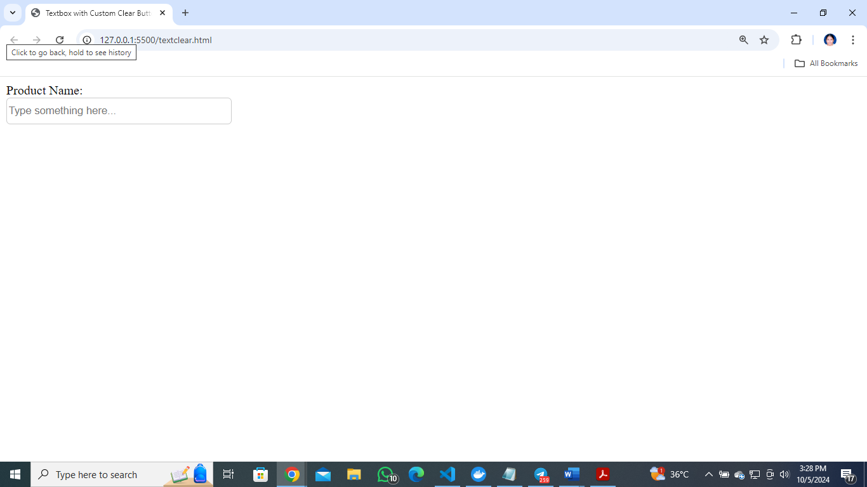

16) Write HTML code to for following Output

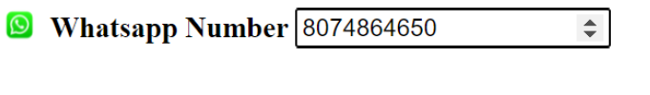

<!DOCTYPE html>

<html lang="en">

<head>

    <meta charset="UTF-8">

    <meta name="viewport" content="width=device-width, initial-scale=1.0">

    <title>Increment/Decrement Number Input</title>

</head>

<body>

<h3>Select Quantity</h3>

<form action="/submit" method="post">

    <i class="fa fa-whatsapp"></i><label for="quantity">WhatsApp Number</label>

    <input type="number" id="quantity" name="quantity" min="1111111111" max="9999999999" value="1" step="1">

    <br><br>

    <input type="submit" value="Submit">

</form>

</body>

</html>

17) Write HTML Code for following output

<!DOCTYPE html>

<html lang="en">

<head>

    <meta charset="UTF-8">

    <meta name="viewport" content="width=device-width, initial-scale=1.0">

    <title>Checkbox Example</title>

</head>

<body>

<form action="/submit" method="post">

    <label><input type="checkbox" name="hobby" value="reading"> I Accepts Licence Agrement</label><br>

    <br>

    <input type="submit" value="Submit">

</form>

</body>

</html>

18) Write HTML code for following output

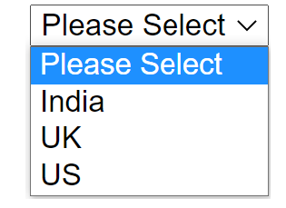

<!DOCTYPE html>

<html lang="en">

<head>

    <meta charset="UTF-8">

    <meta name="viewport" content="width=device-width, initial-scale=1.0">

    <title>Country Dropdown</title>

</head>

<body>

<form action="/submit" method="post">

    <label for="country">Select Country:</label>

    <select name="country" id="country" required>

        <option value="">--Select Country--</option>

        <option value="india">India</option>

        <option value="us">US</option>

        <option value="uk">UK</option>

    </select>

    <br><br>

    <input type="submit" value="Submit">

</form>

</body>

</html>

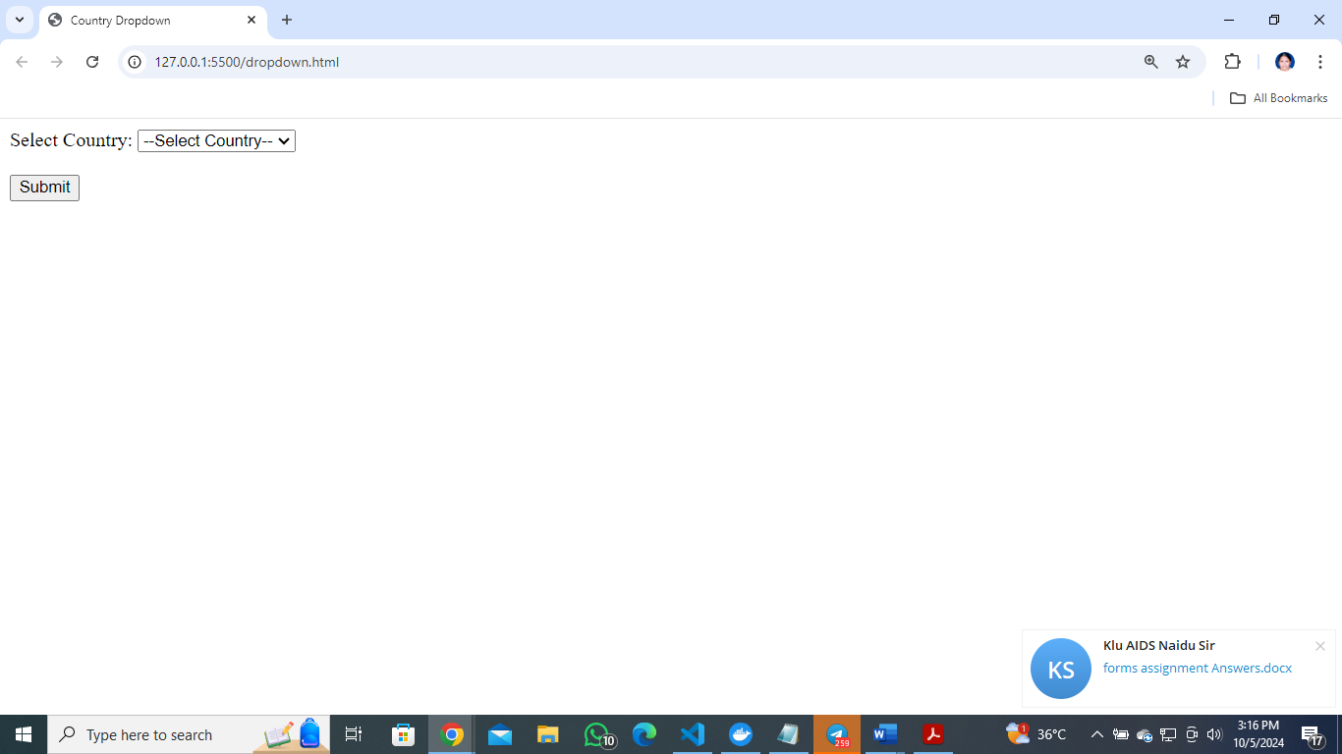

19) implement the below form

<!DOCTYPE html>

<html lang="en">

<head>

    <meta charset="UTF-8">

    <meta name="viewport" content="width=device-width, initial-scale=1.0">

    <title>Registration Form</title>

    <style>

        body {

            background-color: #f9f9f9;

            font-family: Arial, sans-serif;

            text-align: center;

        }

        table {

            width: 70%;

            margin: 20px auto;

            background-color: #ffffff;

            border-collapse: collapse;

            box-shadow: 0 4px 8px rgba(0, 0, 0, 0.1);

        }

        th, td {

            padding: 10px;

            text-align: left;

        }

        th {

            background-color: #4CAF50;

            color: white;

        }

        input[type="text"],

        input[type="email"],

        input[type="tel"],

        input[type="date"],

        textarea {

            width: 100%;

            padding: 8px;

            margin-top: 5px;

            margin-bottom: 10px;

            border: 1px solid #ccc;

            border-radius: 4px;

        }

        input[type="submit"] {

            background-color: #4CAF50;

            color: white;

            padding: 10px 20px;

            border: none;

            border-radius: 4px;

            cursor: pointer;

        }

        input[type="submit"]:hover {

            background-color: #45a049;

        }

    </style>

</head>

<body>

<h2>Registration Form</h2>

<form action="/submit" method="post">

    <table>

        <tr>

            <th>Field</th>

            <th>Input</th>

        </tr>

        <tr>

            <td>First Name</td>

            <td><input type="text" name="firstname" required></td>

        </tr>

        <tr>

            <td>Last Name</td>

            <td><input type="text" name="lastname" required></td>

        </tr>

        <tr>

            <td>Email ID</td>

            <td><input type="email" name="email" required></td>

        </tr>

        <tr>

            <td>Mobile No</td>

            <td><input type="tel" name="mobile" required></td>

        </tr>

        <tr>

            <td>Gender</td>

            <td>

                <input type="radio" name="gender" value="male" required> Male

                <input type="radio" name="gender" value="female"> Female

            </td>

        </tr>

        <tr>

            <td>Date of Birth</td>

            <td><input type="date" name="dob" required></td>

        </tr>

        <tr>

            <td>Address</td>

            <td><textarea name="address" rows="4" required></textarea></td>

        </tr>

        <tr>

            <td>City</td>

            <td><input type="text" name="city" required></td>

        </tr>

        <tr>

            <td>Pincode</td>

            <td><input type="text" name="pincode" required></td>

        </tr>

        <tr>

            <td>State</td>

            <td><input type="text" name="state" required></td>

        </tr>

        <tr>

            <td>Country</td>

            <td><input type="text" name="country" required></td>

        </tr>

        <tr>

            <td>Hobbies</td>

            <td>

                <input type="checkbox" name="hobbies" value="reading"> Reading

                <input type="checkbox" name="hobbies" value="traveling"> Traveling

                <input type="checkbox" name="hobbies" value="gaming"> Gaming

            </td>

        </tr>

        <tr>

            <td>Qualification</td>

            <td>

                <input type="checkbox" name="qualification" value="high_school"> High School

                <input type="checkbox" name="qualification" value="bachelor"> Bachelor’s

                <input type="checkbox" name="qualification" value="master"> Master’s

            </td>

        </tr>

        <tr>

            <td>Courses Applied For</td>

            <td>

                <input type="checkbox" name="courses" value="course1"> Course 1

                <input type="checkbox" name="courses" value="course2"> Course 2

                <input type="checkbox" name="courses" value="course3"> Course 3

            </td>

        </tr>

        <tr>

            <td colspan="2">

                <input type="submit" value="Submit">

            </td>

        </tr>

    </table>

</form>

</body>

</html>

**CSS Positions:**

1. Explain Positions in CSS?

Ans:

Types of CSS Positions

• Relative

• Absolute

• Fixed

• Sticky

• Static

1. What are the Differences Between Absolute and Relative Positions?

Ans:

**Relative :** moving element from its original position (actual position)

**Absolute**

✓ move element with respect to ancestor(parent)

1. Implement The Below Application Absolute Position

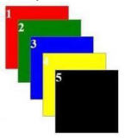

Ans:

<!DOCTYPE html>

<html lang="en">

<head>

<title>Absolute Position</title>

<style>

.common{

width: 100px;

height: 100px;

border: 1px solid gray;

}

.c1{

background-color: red;

}

.c2{

position: absolute;

left: 20px;

bottom: 80px;

background-color: green;

}

.c3{

position: absolute;

left: 40px;

bottom: 150px;

background-color: blue;

z-index: 10;

}

.c4{

position: absolute;

left: 100px;

bottom: 200px;

background-color: yellowgreen;

z-index: 9;

}

.c5{

position: absolute;

left: 120px;

top: 10px;

background-color: brown;

}

</style>

</head>

<body>

<div class="common c1">1</div>

<div class="common c2">2</div>

<div class="common c3">3</div>

<div class="common c4">4</div>

<div class="common c5">5</div>

</body>

</html>

1. Implement the Below Application with CSS Relative Position



Ans:

<!DOCTYPE html>

<html lang="en">

<head>

<title>Relative Position</title>

<style>

.common{

width: 100px;

height: 100px;

border: 1px solid gray;

}

.c1{

background-color: red;

}

.c2{

position: relative;

left: 20px;

bottom: 80px;

background-color: green;

}

.c3{

position: relative;

left: 40px;

bottom: 150px;

background-color: blue;

z-index: 10;

}

.c4{

position: relative;

left: 100px;

bottom: 200px;

background-color: yellowgreen;

z-index: 9;

}

.c5{

position: relative;

left: 120px;

top: 10px;

background-color: brown;

}

</style>

</head>

<body>

<div class="common c1">1</div>

<div class="common c2">2</div>

<div class="common c3">3</div>

<div class="common c4">4</div>

<div class="common c5">5</div>

</body>

</html>

1. What is Z-Index in CSS?

Ans:

z-index property specifies the stack order of an element.

An element with highest stack order will display on top

**Syntax: z-index:10;**

1. Which one is the default position in CSS: Ans: Static

Ans:

1. How to display Element in center of webpage

Ans:

1. What is border-box in CSS?

Ans:

**Box Sizing**

✓ adjusting padding, border and margin with in the actual width and

height of an element called as **border-box**

✓ this feature introduced in **CSS3.X**

Syntax: **box-sizing: border-box;**